**GAMING CENTER DATABASE – DBMS PROJECT**

**ER DIAGRAM FOR ONLINE GAMING DATABASE:**

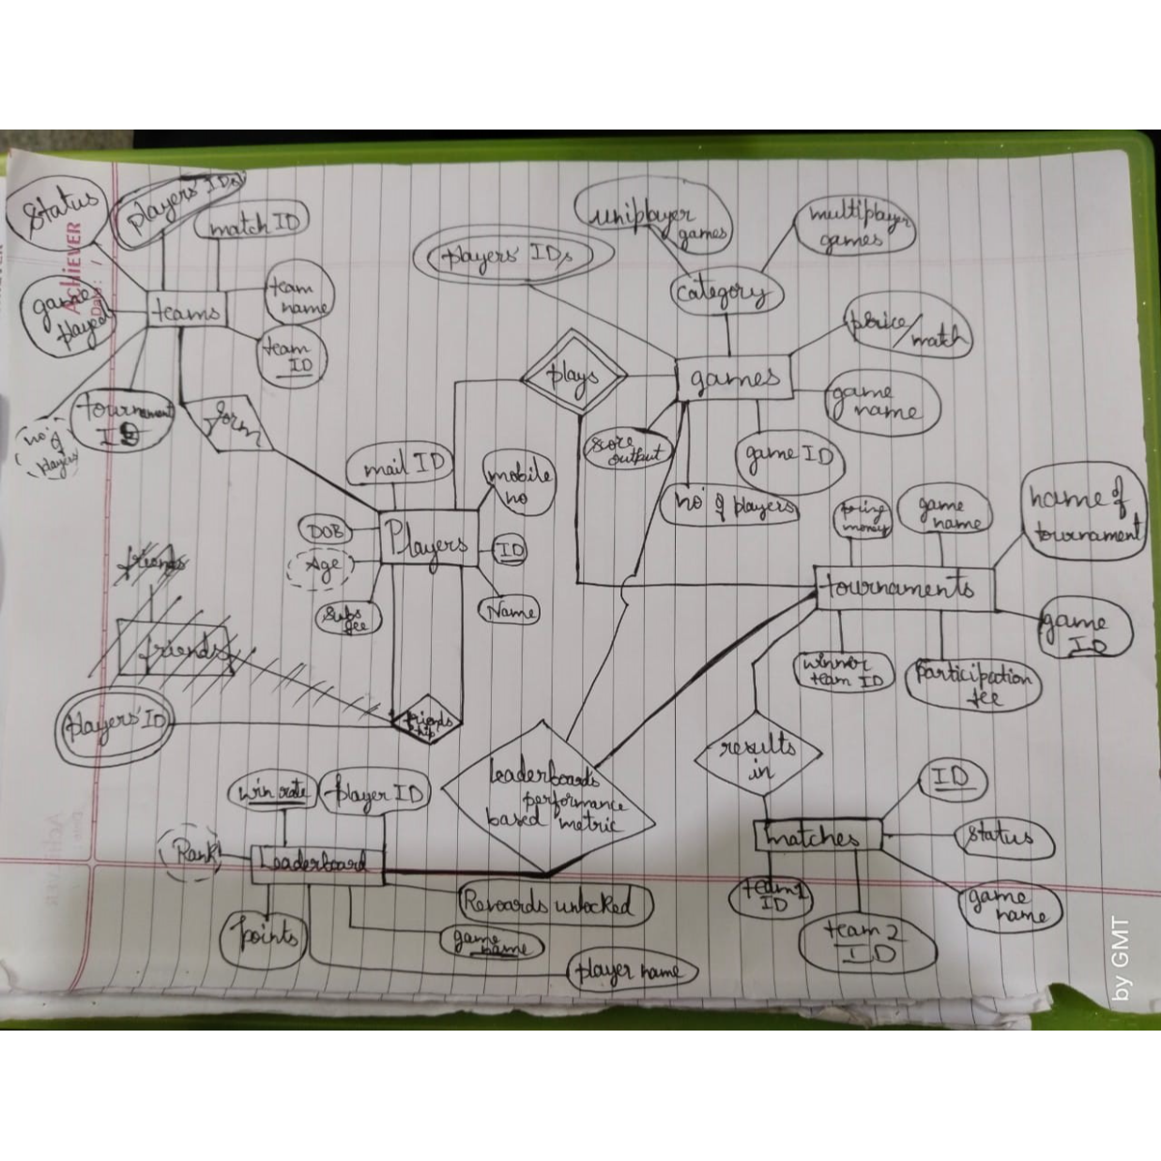

**ER RELATIONAL SCHEMA FOR ONLINE GAMING DATABASE:**

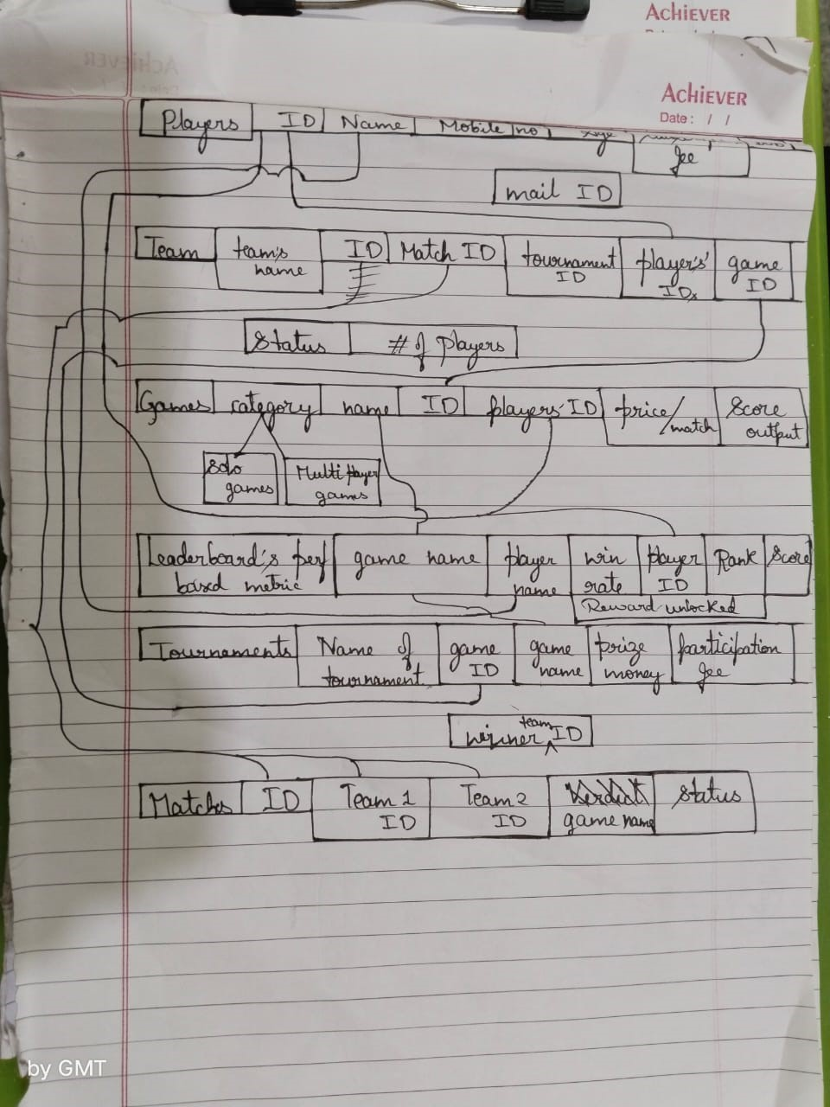

**USER REQUIREMENT SPECIFICATION FOR ONLINE GAMING DATBASE:**

Date: 2023-10-05

1. **Introduction**

This document describes the user requirements for the schema provided in the image. The schema is used to represent data about players and tournaments in a gaming Centre.

2. **Scope**

The schema covers the following entities:

* Player: A player in the game.
* Game: A game that players can participate in.
* Tournament: A competition between players or teams.

The schema also covers the following relationships between entities:

* A player can participate in multiple games.
* A game is associated with a single tournament.
* A tournament has one or more matches.
* A match has two teams.

3. **Requirements**

The schema must be able to represent the following data:

* Player information, such as name, email address, and team.
* Game information, such as name, category, and start time.
* Tournament information, such as name, game ID, and prize money.
* Match information, such as team IDs, verdict, and status.

The schema must also be able to support the following queries:

* Get all players who have participated in each game.
* Get all games that a given player has participated in.
* Get all tournaments that a given game is associated with.
* Get all matches that a given tournament has.
* Get the leaderboard for a given game, based on a given metric.

4. **Non-Functional Requirements**

The schema must be easy to understand and use. It should be well-documented and have clear and concise naming conventions.

5. **Use Cases**

The following use cases describe how the schema will be used:

* A game developer uses the schema to create a database of players, games, and tournaments.
* A game developer uses the schema to implement the leaderboard for their game.
* A tournament organizer uses the schema to track the results of matches and generate a leaderboard for their tournament.
* A player uses the schema to view their own stats and the stats of other players.

6. **Success Criteria**

The schema will be considered successful if it meets all of the following criteria:

* It can represent all the data required by the use cases.
* It is easy to understand and use.
* It is well-documented and has clear and concise naming conventions.

7. **Approvals**

This document must be approved by the following stakeholders:

* Game developer
* Tournament organizer
* Player representative